PROCUREMENT DOCUMENTS

Prequalification Document for
Procurement of

Lot 1: Millennium Highway to Cul De Sac Roundabout
Lot 2: Cul De Sac to Anse La Raye Road and Anse La Raye Bridge
Lot 3: Anse La Raye to Soufriere Road

Project: Millennium Highway and West Coast Road Reconstruction
Invitation for Prequalification No.: 2020-001-01
ICB No.:
Employer: Government of Saint Lucia, Department of Infrastructure, Ports and Energy
Country: Saint Lucia
Issued on February 20, 2020

Preface
This Prequalification Document for Procurement of Works (PQD) has been prepared by the Caribbean Development Bank and reflects the structure and the provisions of the Master Procurement Document “Prequalification Document for Procurement of Works” issued by the Multilateral Development Banks and International Financial Institutions, except where specific considerations of the procurement policies of the Caribbean Development Bank have required a change. This PQD incorporates the new features of the January 2006 Guidelines for Procurement.

Contents

PART 1 – Prequalification Procedures 1-1
Section I. Instructions to Applicants 1-3
Section II. Prequalification Data Sheet 1-15
Section III. Qualification Criteria and Requirements 1-19
Section IV. Application Forms 1-27
Section V. Eligible Countries 1-43
PART 2 – Works Requirements 2-1
Section VI. Scope of Works 2-1

PART 1 – Prequalification Procedures

Section I. Instructions to Applicants
Table of Clauses
A. General 1-4
1. Scope of Application 1-4
2. Source of Funds 1-4
3. Fraud and Corruption 1-4
4. Eligible Applicants 1-5
5. Eligible Goods and Related Services 1-8
B. Contents of the Prequalification Document 1-8
6. Sections of Prequalification Document 1-8
7. Clarification of Prequalification Document 1-9
8. Amendment of Prequalification Document 1-9
C. Preparation of Applications 1-9
9. Cost of Applications 1-9
10. Language of Application 1-10
11. Documents Comprising the Application 1-10
12. Application Submission Form 1-10
13. Documents Establishing the Eligibility of the Applicant 1-10
14. Documents Establishing the Qualifications of the Applicant 1-10
15. Signing of the Application and Number of Copies 1-10
D. Submission of Applications 1-11
16. Sealing and Identification of Applications 1-11
17. Deadline for Submission of Applications 1-11
18. Late Applications 1-11
19. Opening of Applications 1-11
E. Procedures for Evaluation of Applications 1-12
20. Confidentiality 1-12
21. Clarification of Applications 1-12
22. Responsiveness of Applications 1-12
23. Domestic Bidder Price Preference 1-12
24. Subcontractors 1-12
F. Evaluation of Applications and Prequalification of Applicants 1-13
25. Evaluation of Applications 1-13
26. Employer’s Right to Accept or Reject Applications 1-13
27. Prequalification of Applicants 1-13
28. Notification of Prequalification 1-13
29. Invitation to Bid 1-13
30. Changes in Qualifications of Applicants 1-14

Section I. Instructions to Applicants

A. General
1. Scope of Application | 1.1 In connection with the Invitation for Prequalification indicated in Section II, Prequalification Data Sheet (PDS), the Employer, as defined in the PDS, issues this Prequalification Document (PQD) to applicants interested in bidding for the works described in Section VI, Scope of Works. The number of contracts and the name and identification of each contract, and the International Competitive Bidding (ICB) number corresponding to this prequalification, are provided in the PDS.
2. Source of Funds | 2.1 The Recipient of CDB financing indicated in the PDS has applied for or received financing (hereinafter called “funds”) from CDB towards the cost of the project named in the PDS. The Recipient of CDB financing intends to apply a portion of the funds to eligible payments under the contract(s) resulting from the bidding for which this prequalification is issued.
3. Fraud and Corruption | 3.1 It is CDB’s policy to require that Recipients of CDB Financing as well as bidders, suppliers, and contractors and their subcontractors under Bank-financed contracts, observe the highest standard of ethics during the procurement and execution of such contracts. In pursuance of this policy, CDB:  (a) defines, for the purposes of this provision, the terms set forth below as follows:  (i) “corrupt practice” is the offering, giving, receiving or soliciting, directly or indirectly, of anything of value to influence improperly the actions of another party;  (ii) “fraudulent practice” is any act or omission, including a misrepresentation, that knowingly or recklessly misleads, or attempts to mislead, a party to obtain a financial or other benefit or to avoid an obligation;  (iii) “collusive practice” is an arrangement between two or more parties designed to achieve an improper purpose, including to influence improperly the actions of another party;  (iv) “coercive practice” is impairing or harming, or threatening to impair or harm, directly or indirectly, any party or the property of the party to influence improperly the actions of a party;  (v) "obstructive practice" is  (aa) deliberately destroying, falsifying, altering or concealing of evidence material to the investigation or making false statements to investigators in order to materially impede a CDB investigation into allegations of a corrupt, fraudulent, coercive or collusive practice; and/or threatening, harassing or intimidating any party to prevent it from disclosing its knowledge of matters relevant to the investigation or from pursuing the investigation; or  (bb) acts intended to materially impede the exercise of CDB’s inspection and audit rights provided for under sub-clause 3.1 (e) below.  (b) will reject a proposal for award if it determines that the bidder recommended for award has, directly or through an agent, engaged in corrupt, fraudulent, collusive, coercive or obstructive practices in competing for the contract in question;  (c) will cancel the portion of CDB Financing allocated to a contract if it determines at any time that representatives of the Recipient of CDB Financing or of a beneficiary of the CDB financing engaged in corrupt, fraudulent, collusive, coercive, or obstructive practices during the procurement or the execution of that contract, without the Recipient of CDB Financing having taken timely and appropriate action satisfactory to CDB to address such practices when they occur;  (d) will sanction a firm or individual, including declaring ineligible, either indefinitely or for a stated period of time, to be awarded a CDB-financed contract if it at any time determines that the firm has, directly or through an agent, engaged in corrupt, fraudulent, collusive, coercive or obstructive practices in competing for, or in executing, a CDB-financed contract; and  (e) will have the right to require that a provision be included in bidding documents and in contracts financed by CDB, requiring bidders, suppliers, and contractors and their sub-contractors to permit CDB to inspect their accounts and records and other documents relating to the bid submission and contract performance and to have them audited by auditors appointed by CDB.
4. Eligible Applicants | 4.1 An Applicant shall be a private, public or government owned legal entity, subject to ITA 4.8, or any combination of them in the form of association(s) including Joint Venture (JV) with the formal intent, as evidenced by a letter of intent, to enter into an agreement or under an existing agreement. In the case of a JV, unless otherwise specified in the PDS, (i) all parties shall be jointly and severally liable, and (ii) there shall be no limit on the number of partners.
 | 4.2 The eligibility criteria listed in this Clause 4 shall apply to the Applicant, including the parties constituting the Applicant, i.e., its proposed partners, subcontractors or suppliers for any part of the Contract including related services.
 | 4.3 Subject of Sub-Clause 4.11, an Applicant shall be eligible for procurement if:
 |  | (a) | in the case of a body corporate, it is legally incorporated or otherwise organised in an eligible country, has its principle place of business in an eligible country and is either:
 |  |  | (i) | more than 50% beneficially owned by a citizen or citizens and/or a bona fide resident or residents of an eligible country or countries or by a body corporate or bodies corporate meeting these requirements; or
 |  |  | (ii) | owned or controlled by the government of an eligible country provided that it can establish that:
 |  |  |  | (aa) | it is legally and financially autonomous;
 |  |  |  | (bb) | operates under commercial law; and
 |  |  |  | (cc) | are not dependent agencies of the eligible country,
 |  | (b) | in the case of individuals, the person or persons is or are a citizen or citizens or bona fide resident or residents of an eligible country; and
 |  | (c) | in all cases, the bidder has no arrangement and undertakes not to make any arrangement whereby any substantial part of the net profits or other tangible benefits of the contract will accrue or be paid to a person not a citizen or bona fide resident of an eligible country.
 | 4.4 Applicants and all parties constituting the Applicant shall not have a conflict of interest. Applicants shall be considered to have a conflict of interest, if they participated as a consultant in the preparation of the design or technical specifications of the Works that are the subject of this prequalification. Where a firm, or a firm from the same economic or financial group, in addition to consulting, also has the capability to manufacture or supply goods or to construct works, that firm, or a firm from the same economic or financial group, cannot normally be a supplier of goods or works, if it provided consulting services for the contract corresponding to this prequalification, unless it can be demonstrated that there is not a significant degree of common ownership, influence or control.
 | 4.5 An Applicant shall submit only one application in the same Prequalification process, either individually as an Applicant or as a partner of a joint venture. No Applicant can be a subcontractor while submitting an application individually or as a partner of a joint venture in the same Prequalification process. A Subcontractor in any application may participate in more than one application, but only in that capacity. An Applicant who submits, or participates in, more than one application will cause all the applications in which the Applicant has participated to be disqualified.
 | 4.6 A firm that has been determined to be ineligible by the Bank in relation to the Bank guidelines on preventing and combating Fraud and Corruption in CDB-financed projects shall be not be eligible to be awarded a contract.
 | 4.7 An Applicant that is under a declaration of ineligibility by CDB in accordance with ITA 3, at the date of submission of the application or thereafter, shall be disqualified. CDB maintains a list of firms and individuals that have been sanctioned by the Bank pursuant to Sub-Clause 3.1 (d) and are not eligible to participate in procurement financed by the Bank.
 | 4.8 Government-owned entities in an eligible country shall be eligible only if they can establish that they are legally and financially autonomous, and operate under commercial law, and that they are not dependent agencies of the eligible country.

 | 4.9 Applicants shall not be under suspension for violation of a Bid–Securing Declaration in the Employer’s Country.
 | 4.10 Applicants and all parties constituting the Applicant shall provide such evidence of their continued eligibility satisfactory to the Employer, as the Employer shall reasonably request.
 | 4.11 Applicants from an eligible country may be excluded if, (a) as a matter of law or official regulations the country of the Recipient of CDB Financing prohibits commercial relations with that country, provided that CDB is satisfied that such exclusion does not preclude effective competition for the supply of goods or the contracting of works required; or (b) by an act of compliance with a decision of the United Nations Security Council taken under Chapter VII of the Charter of the United Nations, the country of the Recipient of CDB Financing prohibits any import of goods or contracting of works or services from that country, or any payments to persons or entities in that country. Section VI, Eligible Countries provide a list of ineligible countries pursuant to this Sub Clause 4.11.
5. Eligible Goods and Related Services | 5.1 All goods and related services to be supplied under the Contract to be financed by CDB shall have as their origin in any eligible country in accordance with Section V, Eligible Countries.

 | B. Contents of the Prequalification Document
6. Sections of Prequalification Document | 6.1 The document for the prequalification of Applicants (hereinafter - “prequalification document”) consists of parts 1 and 2 which comprise all the sections indicated below and should be read in conjunction with any Addendum issued in accordance with ITA 8.
PART 1 Prequalification Procedures
- Section I. Instructions to Applicants (ITA)
- Section II. Prequalification Data Sheet (PDS)
- Section III Qualification Criteria and Requirements
- Section IV. Application Forms
- Section V. Eligible Countries
PART 2 Works Requirements
- Section VI. Scope of Works

 | 6.2 The “Invitation for Prequalification Applications” issued by the Employer is not part of the prequalification document. A sample form is provided as an attachment to this Prequalification Document for information only.
 | 6.3 The Employer accepts no responsibility for the completeness of the prequalification document and its addenda unless they were obtained directly from the Employer.
 | 6.4 The Applicant is expected to examine all instructions, forms, and terms in the Prequalification Document and to furnish all information or documentation required by the Prequalification Document.
7. Clarification of Prequalification Document | 7.1 A prospective Applicant requiring any clarification of the Prequalification Document shall contact the Employer in writing at the Employer’s address indicated in the PDS. The Employer will respond in writing to any request for clarification provided that such request is received no later than fourteen (14) days prior to the deadline for submission of applications. The Employer shall forward copies of its response to all applicants who have acquired the prequalification document directly from the Employer including a description of the inquiry but without identifying its source. Should the Employer deem it necessary to amend the prequalification document as a result of a clarification, it shall do so following the procedure under ITA 8 and in accordance with the provisions of ITA 17.2.

8. Amendment of Prequalification Document | 8.1 At any time prior to the deadline for submission of applications, the Employer may amend the Prequalification Document by issuing addenda.
 | 8.2 Any addendum issued shall be part of the Prequalification Document and shall be communicated in writing to all who have obtained the prequalification document from the Employer.
 | 8.3 To give prospective Applicants reasonable time to take an addendum into account in preparing their applications, the Employer may, at its discretion, extend the deadline for the submission of applications.
 | C. Preparation of Applications
9. Cost of Applications | 9.1 The Applicant shall bear all costs associated with the preparation and submission of its application. The Employer will in no case be responsible or liable for those costs, regardless of the conduct or outcome of the prequalification process.

10. Language of Application | 10.1 The application as well as all correspondence and documents relating to the prequalification exchanged by the Applicant and the Employer, shall be written in English. Supporting documents and printed literature that are part of the application may be in another language, provided they are accompanied by an accurate translation of the relevant passages in English, in which case, for purposes of interpretation of the application, the translation shall govern.
11. Documents Comprising the Application | 11.1 The application shall comprise the following:  (a) Application Submission Form, in accordance with ITA 12;  (b) documentary evidence establishing the Applicant’s eligibility to prequalify, in accordance with ITA 13;  (c) documentary evidence establishing the Applicant’s qualifications, in accordance with ITA 14; and  (d) any other document required as specified in the PDS.
12. Application Submission Form | 12.1 The Applicant shall prepare an Application Submission Sheet using the form furnished in Section IV, Application Forms. This Form must be completed without any alteration to its format.

13. Documents Establishing the Eligibility of the Applicant | 13.1 To establish its eligibility in accordance with ITA 4, the Applicant shall complete the eligibility declarations in the Application Submission Form and Forms ELI (eligibility) 1.1 and 1.2, included in Section IV, Application Forms.
14. Documents Establishing the Qualifications of the Applicant | 14.1 To establish its qualifications to perform the contract(s) in accordance with Section III, Qualification Criteria and Requirements, the Applicant shall provide the information requested in the corresponding Information Sheets included in Section IV, Application Forms.
15. Signing of the Application and Number of Copies | 15.1 The Applicant shall prepare one original of the documents comprising the application as described in ITA 11 and clearly mark it “ORIGINAL”. The original of the application shall be typed or written in indelible ink and shall be signed by a person duly authorized to sign on behalf of the Applicant.  15.2 The Applicant shall submit copies of the signed original application, in the number specified in the PDS, and clearly mark them “COPY”. In the event of any discrepancy between the original and the copies, the original shall prevail
 | D. Submission of Applications
16. Sealing and Identification of Applications | 16.1 The Applicant shall enclose the original and the copies of the application in a sealed envelope that shall:  (a) bear the name and address of the Applicant;  (b) be addressed to the Employer, in accordance with ITA 17.1; and  (c) bear the specific identification of this prequalification process indicated in the PDS 1.1.
 | 16.2 The Employer will accept no responsibility for not processing any envelope that was not identified as required.
17. Deadline for Submission of Applications | 17.1 Applicants may always submit their applications by mail or by hand. When so specified in the PDS, applicants shall have the option of submitting their applications electronically, in accordance with electronic application submission procedures specified in the PDS. Applications shall be received by the Employer at the address and no later than the deadline indicated in the PDS. A receipt will be given for all applications submitted.

 | 17.2 The Employer may, at its discretion, extend the deadline for the submission of applications by amending the Prequalification Document in accordance with ITA 8, in which case all rights and obligations of the Employer and the Applicants subject to the previous deadline shall thereafter be subject to the deadline as extended.
18. Late Applications | 18.1 Any application received by the Employer after the deadline for submission of applications prescribed in accordance with ITA 17 will be treated as indicated in the PDS.
19. Opening of Applications | 19.1 Any specific electronic application opening procedures required if electronic submission of applications is permitted pursuant to Sub Clause 17.1 shall be as specified in the PDS. Employer shall prepare a record of the opening of applications that shall include, as a minimum, the name of the Applicant. A copy of the record shall be distributed to all Applicants.

 | E. Procedures for Evaluation of Applications
20. Confidentiality | 20.1 Information relating to the evaluation of applications, and recommendation for prequalification, shall not be disclosed to Applicants or any other persons not officially concerned with such process until the notification of prequalification is made to all Applicants.
 | 20.2 From the deadline for submission of applications to the time of notification of the results of the prequalification in accordance with ITA 28, any Applicant that wishes to contact the Employer on any matter related to the prequalification process, may do so but only in writing.
21. Clarification of Applications | 21.1 To assist in the evaluation of applications, the Employer may, at its discretion, ask any Applicant for a clarification of its application which shall be submitted within a stated reasonable period of time. Any request for clarification and all clarifications shall be in writing.
 | 21.2 If an Applicant does not provide clarifications of the information requested by the date and time set in the Employer’s request for clarification, its application may be rejected.
22. Responsiveness of Applications | 22.1 The Employer may reject any application which is not responsive to the requirements of the prequalification document.

23. Regional Bidder Price Preference | 23.1 Unless otherwise specified in the PDS, a margin of preference for regional bidders shall not apply in the bidding process resulting from this prequalification.
24. Subcontractors | 24.1 Applicants planning to subcontract any of the key activities indicated in Section III, Qualification Criteria, shall specify the activity(ies) or parts of the works to be subcontracted in the Application Submission Form. Applicants shall clearly identify the proposed specialist subcontractors in Forms ELI-1.2 and EXP (experience)-4.2(b) in Section IV. Such proposed specialist subcontractor(s) shall meet the corresponding qualification requirements specified in Section III, Qualification Criteria and Requirements.
 | 24.2 At this time, the Employer does not intend to execute certain specific parts of the Works by subcontractors selected in advance by the Employer (Nominated Subcontractors) unless otherwise stated in the PDS.
 | F. Evaluation of Applications and Prequalification of Applicants
25. Evaluation of Applications | 25.1 The Employer shall use the factors, methods, criteria, and requirements defined in Section III, Qualification Criteria and Requirements to evaluate the qualifications of the Applicants. The use of other methods, criteria, or requirements shall not be permitted. The Employer reserves the right to waive minor deviations in the qualification criteria if they do not materially affect the capability of an Applicant to perform the contract.
 | 25.2 Only the qualifications of subcontractors that have been identified in the application may be considered in the evaluation of an Applicant. However, the general experience and financial resources of subcontractors may not be added to those of the Applicant for purposes of prequalification of the Applicant.
 | 25.3 In case of multiple contracts, the Employer shall prequalify each Applicant for the maximum number and types of contracts for which the Applicant meets the appropriate aggregate requirements of such contracts, as specified in Section III, Qualification Criteria and Requirements.
26. Employer’s Right to Accept or Reject Applications | 26.1 The Employer reserves the right to accept or reject any application, and to annul the prequalification process and reject all applications at any time, without thereby incurring any liability to Applicants.
27. Prequalification of Applicants | 27.1 All Applicants whose applications have met or exceeded (“passed”) the specified threshold requirements will, to the exclusion of all others, be prequalified by the Employer.

28. Notification of Prequalification | 28.1 Once the Employer has completed the evaluation of the applications it shall notify all Applicants in writing of the names of those applicants who have been prequalified.
29. Invitation to Bid | 29.1 Promptly after the notification of the results of the prequalification the Employer shall invite bids from all the Applicants that have been prequalified.

 | 29.2 Bidders may be required to provide a Bid Security or a Bid Securing Declaration acceptable to the Employer in the form and an amount to be specified in the Bidding Documents, and the successful Bidder shall be required to provide a Performance Security to be specified in the Bidding Documents.
30. Changes in Qualifications of Applicants | 30.1 Any change in the structure or formation of an Applicant after being prequalified in accordance with ITA 27 and invited to bid shall be subject to a written approval of the Employer prior to the deadline for submission of bids. Such approval shall be denied if as a consequence of the change the Applicant no longer substantially meets the qualification criteria set forth in Section III, Qualification Criteria and Requirements, or if in the opinion of the Employer, a substantial reduction in competition may result. Any such changes shall be submitted to the Employer not later than 14 days after the date of the Invitation for Bids.

Section II. Prequalification Data Sheet (PDS)
A. General
ITA 1.1 | The Employer is: Government of Saint Lucia, Department of Infrastructure, Ports and Energy
ITA 1.1 | The list of contracts is:  - Lot 1: Millennium Highway to Cul-de-Sac Roundabout  - Lot 2: Cul-de-Sac to Anse La Raye Road and Anse La Raye Bridge  - Lot 3: Anse La Raye to Soufriere Road  - Any combination of Lots
ITA 1.1 | ICB name and number are:  - Lot 1: Millennium Highway to Cul-de-Sac Roundabout  - Lot 2: Cul-de-Sac to Anse La Raye Road and Anse La Raye Bridge  - Lot 3: Anse La Raye to Soufriere Road  - Any combination of Lots
ITA 2.1 | The name of the Recipient of CDB Financing is: The Government of St. Lucia represented by the Ministry of Infrastructure, Ports, Energy and Labour
ITA 2.1 | The name of the Project is: Millennium Highway and West Coast Road Reconstruction
ITA 4.1 | (i) The parties in a JV shall be jointly and severally liable.  (ii) Maximum number of partners in the JV shall be: Two (2)
B. Contents of the Prequalification Document
ITA 7.1 | For clarification purposes, the Employer's address is:  Attention: Project Coordinator, Special Projects Unit  Address: Union, Building Complex  City: Castries  Country: Saint Lucia  Telephone: 1 758 468-4300 / 468-4370  Electronic mail address: rphilogene@gosl.gov.lc

C. Preparation of Applications
ITA 10.1 | The language of the application as well as of all correspondence is English
ITA 11.1 (d) | The Applicant shall submit with its application, the following additional documents: Not Applicable
ITA 15.2 | In addition to the original, the number of copies to be submitted with the application is: Three (3)
D. Submission of Applications
ITA 17.1 | Applicants shall have the option of submitting their applications electronically.  If electronic submission of applications shall be permitted, the electronic application submission procedures shall be:  By electronic submission to the email address indicated in below. The “Subject” field of the email message must read: “Application to Prequalify for the Millennium Highway and West Coast Road Upgrade Project, Ref. No. [LOT No._]”. The submission will be deemed to have been received at the time that it is received by The Secretary, Central TendersBoard. The burden of proving receipt of the e-mail will be on the applicant and will not be met solely by a read receipt or sent items report generated by the bidder’s computer.; or  For application submission purposes only, the Employer's address is:
Attention: The Secretary, Central Tenders Board
Address: 2nd Floor Financial Administrative Centre, Point Seraphine
City: Castries
Country: Saint Lucia
Email: sking@gosl.gov.lc

The deadline for application submission is:
Date: March 19, 2020 Time: 12:00 p.m.
ITA 18.1 | Late applications will be returned unopened to the Applicants.
ITA 19.1 | If electronic submission of applications shall be permitted, electronic application opening procedures are: Not Applicable
E. Procedures for Evaluation of Applications
ITA 23.1 | A margin of preference shall not apply for eligible regional bidders.
ITA 24.2 | At this time the Employer does not intend to execute certain specific parts of the Works by subcontractors selected in advance (Nominated Subcontractors).

Section III. Qualification Criteria and Requirements
This Section contains all the methods, criteria, and requirements that the Employer shall use to evaluate applications. The information to be provided in relation to each requirement and the definitions of the corresponding terms are included in the respective Application Forms.
Contents

1. Eligibility 20
2. Historical Contract Non-Performance 21
3. Financial Situation 22
4. Experience 24

Eligibility and Qualification Criteria |  |  | Compliance Requirements |  |  |  | Documentation
No. | Subject | Requirement | Single Entity | Joint Venture |  |  | Submission Requirements
 |  |  |  | All Parties Combined | Each Partner | One Partner
1. Eligibility
1.1 | Nationality | Nationality in accordance with ITA Sub-Clause 4.2 | Must meet requirement | Existing or intended JV must meet requirement | Must meet requirement | N/A | Forms ELI – 1.1 and 1.2, with attachments
1.2 | Conflict of Interest | No conflicts of interest in ITA Sub-Clause 4.4 | Must meet requirement | Existing or intended JV must meet requirement | Must meet requirement | N/A | Application Submission Form
1.3 | Bank Ineligibility | Not having been declared ineligible by CDB, as described in ITA Sub-Clause 4.7 | Must meet requirement | Existing JV must meet requirement | Must meet requirement | N/A | Application Submission Form
1.4 | Government Owned Entity | Applicant required to meet conditions of ITA Sub-Clause 4.8 | Must meet requirement | Must meet requirement | Must meet requirement | N/A | Forms ELI – 1.1 and 1.2, with attachments
1.5 | United Nations resolution or law of the country of the Recipient of CDB Financing | Not having been excluded as a result of the laws of the country of the Recipient of CDB Financing or official regulations, or by an act of compliance with UN Security Council resolution, in accordance with ITA 4.11 | Must meet requirement | Must meet requirement | Must meet requirement | N/A | Forms ELI – 1.1 and 1.2, with attachments
2. Historical Contract Non-Performance
2.1 | History of Non-Performing Contracts | Non-performance of a contract did not occur within the last five [5] years prior to the deadline for application submission based on all information on fully settled disputes or litigation. A fully settled dispute or litigation is one that has been resolved in accordance with the Dispute Resolution Mechanism under the respective contract and where all appeal instances available to the applicant have been exhausted. | Must meet requirement by itself or as partner to past or existing JV | N/A | Must meet requirement by itself or as partner to past or existing JV | N/A | Form CON-2
2.2 | Failure to Sign Contract | Not being under execution of a Bid Securing Declaration pursuant to Sub-Clause 4.9 for three [3] years | Must meet requirement | Must meet requirement | Must meet requirement | N/A | Application Submission Form
2.3 | Pending Litigation | All pending litigation shall in total not represent more than 20 %, twenty percent of the Applicant’s net worth and shall be treated as resolved against the Applicant | Must meet requirement by itself or as a partner to past or existing JV | N/A | Must meet requirement by itself or as a partner to past or existing JV | N/A | Form CON – 2
3. Financial Situation
3.1 | Financial Performance | Submission of audited balance sheets or if not required by the law of the Applicant’s country, other financial statements acceptable to the Employer, for the last five [5] years to demonstrate: | Must meet requirement | N/A | Must meet requirement | N/A | Form FIN – 3.1 with attachments
 |  | (a) the current soundness of the applicant’s financial position and its prospective long-term profitability, and | (a) Must meet requirement | (a) N/A | (a) Must meet requirement | (a) N/A
 |  | (b) capacity to have a cash flow amount of  - Lot 1: Millennium Highway to Cul De Sac Roundabout –  [USD$2,446,229.04]  - Lot 2: Cul De Sac to Anse La Raye and Anse La Raye Bridge –  - [USD$1,894,401.90]  - Lot 3: Anse La Raye to Soufriere - [USD$3,417,771.41]  - Lots 1, 2 and 3 / Lots 1 and 2 / Lots 1 and 3 Lots 2 and 3 - [USD$5,391,580.33] | (b) Must meet requirement | (b) Must meet requirement | (b) N/A | (b) N/A
3.2 | Average Annual Construction Turnover | Minimum average annual construction turnover of  - Lot 1: Millennium Highway to Cul De Sac Roundabout - [USD$9,784,916.17]  - Lot 2: Cul De Sac to Anse La Raye and Anse La Raye Bridge –  - [USD$7,577,607.58]  - Lot 3: Anse La Raye to Soufriere - [USD$13,671,085.63]  - Lots 1, 2 and 3 / Lots 1 and 2 / Lots 1 and 3 / Lots 2 and 3 - [USD$21,566,321.33]  calculated as total certified payments received for three [3] contracts in progress or completed, within the last five [5] years.  For more than one lot the amounts will be combined based on combination | Must meet requirement | Must meet requirement | Must meet  50%  Fifty percent of the requirement | Must meet  50%  Fifty percent of the requirement | Form FIN – 3.2
4. Experience
4.1 | General Construction Experience | Experience under construction contracts in the role of contractor, subcontractor, or management contractor for at least the last seven [7] years prior to the application submission deadline, and with activity in at least nine [9] months in each year. | Must meet requirement | N/A | Must meet requirement | N/A | Form EXP – 4.1
4.2 (a) | Specific Construction Experience | Participation as contractor, management contractor or subcontractor, in at least three [3] contracts within the last seven [7] years, each with a value of at least,  - Lot 1: Millennium Highway to Cul De Sac Roundabout - [USD$7,338,687.13]  - Lot 2: Cul De Sac to Anse La Raye and Anse La Raye Bridge - [USD$5,683,205.69]  - Lot 3: Anse La Raye to Soufriere –  [USD$ 10,253,314.22]  - Lots 1, 2 and 3 / Lots 1 and 2 / Lots 1 and 3 / Lots 2 and 3 –  [USD$ 16,174,741.00]  that have been successfully and substantially completed and that are similar to the proposed works. The similarity shall be based on the physical size, complexity, methods/technology or other characteristics as described in Section VI, Scope of Works | Must meet requirement | Must meet requirement | N/A | Must meet require for one contract | Form EXP 4.2(a)
4.2 (b) |  | For the above or other contracts executed during the period stipulated in 4.2 (a) above, a minimum construction experience in the following key activities:  (For Roadworks)  - Asphalt Pavement Reclamation  - Asphalt Paving  - General Road Construction  - General Earth Moving  (Anse La Raye Bridge)  - RC Bridge Construction greater than 10m spans  - River Training  - Gabion Construction  - Concrete Structures below water  - General Earthworks | Must meet requirements | Must meet requirements | N/A | Must meet the required key activities] | Form EXP – 4.2 (b)

Section IV. Application Forms
Table of Forms

Application Submission Form 1-28
Applicant Information Form 1-30
Applicant's Party Information Form 1-31
Historical Contract Non-Performance 1-32
Financial Situation 1-34
Average Annual Construction Turnover 1-36
General Construction Experience 1-37
Similar Construction Experience 1-38
Construction Experience in Key Activities 1-40

Application Submission Form
Date: [insert day, month, year]
ICB No. and title: [insert ICB number and title]

To: [insert full name of Employer]

We, the undersigned, apply to be prequalified for the referenced ICB and declare that:

(a) we have examined and have no reservations to the Prequalification Documents, including Addendum(s) No(s)., issued in accordance with Instructions to Applicants (ITA) Clause 8: [insert the number and issuing date of each addendum].
(b) we, including any subcontractors or suppliers for any part of the contract resulting from this prequalification process, have nationalities from eligible countries, in accordance with ITA Sub-Clause 4.2: [insert the nationality of the Applicant, including that of all partners in case of a Joint Venture, and the nationality of each already identified subcontractor and supplier of related services, if applicable];
(c) we, including any subcontractors or suppliers for any part of the contract resulting from this prequalification, do not have any conflict of interest, in accordance with ITA Sub-Clause 4.4;
(d) we, including any subcontractors or suppliers for any part of the contract resulting from this prequalification, have not been declared ineligible by the Bank, or under the Employer's country laws, official regulations, or under execution of a Bid Securing Declaration in the Employer's Country, or by an act of compliance with a decision of the United Nations Security Council, in accordance with ITA Sub-Clauses 4.7, 4.9 and 4.11;
(e) [insert either "we are not a Government owned entity," or "we are a Government entity, and we meet the requirements of ITA Sub-Clause 4.8];
(f) we, in accordance with ITA Sub-Clause 24.1, plan to subcontract the following key activities and/or parts of the works:
[insert any of the key activities identified in Section III- 4.2 (b) which the Applicant intends to subcontract]
(g) we declare that the following commissions, gratuities, or fees have been paid or are to be paid with respect to the prequalification process, the corresponding bidding process or execution of the Contract:

Name of Recipient | Address | Reason | Amount
[insert full name for each occurrence] | [insert street/ number/city/country] | [indicate reason] | [specify amount in XCD$ equivalent]
________________  ________________  ________________  ________________ | ________________  ________________  ________________  ________________ | ________________  ________________  ________________  ________________ | ________________  ________________  ________________  ________________
[If none has been paid or is to be paid, indicate “none”.]

(h) We understand that you may cancel the prequalification process at any time and that you are neither bound to accept any application that you may receive nor to invite the prequalified applicants to bid for the contract subject of this prequalification, without incurring any liability to the Applicants, in accordance with ITA Clause 26.
Signed [insert signature(s) of an authorized representative(s) of the Applicant]

Name [insert full name of person signing the application]
In the Capacity of [insert capacity of person signing the application]
Duly authorized to sign the application for and on behalf of: Applicant’s Name [insert full name of Applicant] Address [insert street number/town or city/country address]
Dated on [insert day number] day of [insert month], [insert year]

Form ELI -1.1
Applicant Information Form
Date: [insert day, month, year]
ICB No. and title: [insert ICB number and title]
Page [insert page number] of [insert total number] pages

Applicant's legal name
[insert full legal name]
In case of Joint Venture (JV), legal name of each partner:
[insert full legal name of each partner in JV]
Applicant's Actual or Intended country of constitution:
[indicate country of Constitution]
Applicant's actual or Intended year of constitution:
[indicate year of Constitution]
Applicant's legal address in country of constitution:
[insert street/ number/ town or city/ country]
Applicant's authorized representative information
Name: [insert full legal name]
Address: [insert street/ number/ town or city/ country]
Telephone/Fax numbers: [insert telephone/fax numbers, including country and city codes]
E-mail address: [indicate e-mail address]
Attached are copies of original documents of
◻ Articles of Incorporation or Documents of Constitution, and documents of registration of the legal entity named above, in accordance with ITA 4.2.
◻ In case of JV, letter of intent to form JV or JV agreement, in accordance with ITA 4.1.
◻ In case of Government owned entity, documents establishing legal and financial autonomy and compliance with commercial law, in accordance with ITA 4.8.

Form ELI -1.2
Applicant's Party Information Form
[The following form shall be filled in for the Applicant's parties including partner(s) of a joint venture, subcontractors, suppliers and other parties]
Date: [insert day, month, year]
ICB No. and title: [insert ICB number and title]
Page [insert page number] of [insert total number] pages

JV applicant legal name:
[insert full legal name]
Applicant's Party legal name:
[insert full legal name of Applicant's Party]
Applicant's Party country of registration:
[indicate country of registration]
Applicant Party's year of constitution:
[indicate year of constitution]
Applicant Party's legal address in country of constitution:
[insert street/ number/ town or city/ country]
Applicant Party's authorized representative information
Name: [insert full legal name]
Address: [insert street/ number/ town or city/ country]
Telephone/Fax numbers: [insert telephone/fax numbers, including country and city codes]
E-mail address: [indicate e-mail address]
Attached are copies of original documents of
◻ Articles of Incorporation or Documents of Constitution, and Registration Documents of the legal entity named above, in accordance with ITA 4.2.
◻ In case of a Government owned entity, documents establishing legal and financial autonomy and compliance with commercial law, in accordance with ITA 4.8.

Form CON – 2
Historical Contract Non-Performance
[The following table shall be filled in for the Applicant and for each partner of a Joint Venture]
Applicant’s Legal Name: [insert full name]
Date: [insert day, month, year]
Joint Venture Party Legal Name:[insert full name]
ICB No. and title: [insert ICB number and title]
Page [insert page number] of [insert total number] pages
Non-Performing Contracts in accordance with Section III, Qualification Criteria and
Requirements
◻ Contract non-performance did not occur during the [number] years specified in Section III, Qualification Criteria and Requirements, Sub-Factor 2.1.
◻ Contract(s) not performed during the [number] years specified in Section III, Qualification Criteria and Requirements, requirement 2.1
Year | Non performed portion of contract | Contract Identification | Total Contract Amount (current value, USD$ equivalent)
[insert year] | [insert amount and percentage] | Contract Identification: [indicate complete contract name/ number, and any other identification]  Name of Employer: [insert full name]  Address of Employer: [insert street/city/country]  Reason(s) for nonperformance: [indicate main reason(s)] | [insert amount]
Pending Litigation, in accordance with Section III, Qualification Criteria and Requirements
◻ No pending litigation in accordance with Section III, Qualification Criteria and Requirements, Sub-Factor 2.2.
◻ Pending litigation in accordance with Section III, Qualification Criteria and Requirements, Sub-Factor 2.2 as indicated below.

Year | Outcome as Percentage of Total Assets | Contract Identification | Total Contract Amount (current value, USD$ equivalent)
[insert year] | [insert percentage] | Contract Identification: [indicate complete contract name, number, and any other identification]  Name of Employer: [insert full name]  Address of Employer: [insert street/city/country]  Matter in dispute: [indicate main issues in dispute] | [insert amount]

Form FIN – 3.1
Financial Situation
[The following table shall be filled in for the Applicant and for each partner of a Joint Venture]

Applicant’s Legal Name: [insert full name] Date: [insert day, month, year]
Applicant’s Party Legal Name: [insert full name]
ICB No. and title: [insert ICB number and title]
Page [insert page number] of [insert total number] pages
1. Financial data
Financial information in  (USD$ equivalent in 000s) | Historic information for previous [insert number] years,  [insert in words]  (USDD$ equivalent in 000s)
 | Year 1 | Year 2 | Year 3 | Year … | Year n
Information from Balance Sheet
Total Assets (TA)
Total Liabilities (TL)
Net Worth (NW)
Current Assets (CA)
Current Liabilities (CL)
Information from Income Statement
Total Revenue (TR)
Profits Before Taxes (PBT)

2. Financial documents

The Applicant and its parties shall provide copies of the balance sheets and/or financial statements for [number] years pursuant Section III, Qualifications Criteria and Requirements, Sub-factor 3.1. The financial statements shall:

(a) reflect the financial situation of the Applicant or partner to a JV, and not sister or parent companies.

(b) be audited by a certified accountant.

(c) be complete, including all notes to the financial statements.

(d) correspond to accounting periods already completed and audited (no statements for partial periods shall be requested or accepted).

◻ Attached are copies of financial statements (balance sheets, including all related notes, and income statements) for the five (5) years required above; and complying with the requirements
Form FIN - 3.2
Average Annual Construction Turnover
[The following table shall be filled in for the Applicant and for each partner of a Joint Venture]
Applicant's/Joint Venture Partner's Legal Name: [insert full name]
Date: [insert day, month, year]
Applicant's Party Legal Name: [insert full name]
ICB No. and title: [insert ICB number and title]
Page [insert page number] of [insert total number] pages

Annual turnover data (construction only)
Year | Amount and Currency | USD$ equivalent
[indicate year] | [insert amount and indicate currency] | [insert amount in USD$ equiv.]
Average Annual Construction Turnover *
* Average annual construction turnover calculated as total certified payments received for work in progress or completed, divided by the number of years specified in Section III, Qualification Criteria and Requirements, Sub-Factor 3.2.

Form EXP - 4.1
General Construction Experience

[The following table shall be filled in for the Applicant and for each partner of a Joint Venture]

Applicant's/Joint Venture Partner's Legal Name: [insert full name]
Date: [insert day, month, year]
Applicant JV Party Legal Name: [insert full name]
ICB No. and title: [insert ICB number]
Page [insert page number] of [insert total number] pages

[Identify contracts that demonstrate continuous construction work over the past [number] years pursuant to Section III, Qualification Criteria and Requirements, Sub-Factor 4.1. List contracts chronologically, according to their commencement (starting) dates.]
Starting  Month /  Year | Ending  Month /  Year | Contract Identification | Role of  Applicant
[indicate month/ year] | [indicate month/ year] | Contract name: [insert full name]  Brief Description of the Works performed by the  Applicant: [describe works performed briefly]  Amount of contract: [insert amount in USDD$ equivalent]  Name of Employer: [indicate full name]  Address: [indicate street/number/town or city/country] | [insert "Contractor” or "Subcontractor” or "Contract Manager”]
 |  | Contract name: [insert full name]  Brief Description of the Works performed by the  Applicant: [describe works performed briefly]  Amount of contract: [insert amount in USD$ equivalent]  Name of Employer: [indicate full name]  Address: [indicate street/number/town or city/country] | [insert "Contractor” or "Subcontractor” or "Contract Manager”]
 |  | Contract name: [insert full name]  Brief Description of the Works performed by the  Applicant: [describe works performed briefly]  Amount of contract: [insert amount in USD$ equivalent]  Name of Employer: [indicate full name]  Address: [indicate street/number/town or city/country] | [insert "Contractor” or "Subcontractor” or "Contract Manager”]

Form EXP - 4.2(a)
Similar Construction Experience
[The following table shall be filled in for contracts performed by the Applicant, each partner of a Joint Venture, and specialist sub-contractors]
Applicant's/Joint Venture Partner's Legal Name: [insert full name]
Date: [insert day, month, year]
JV Party Name: [insert full name]
ICB No. and title: [insert ICB number and title]
Page [insert page number] of [insert total number] pages
Similar Contract No.  [insert number] of [insert number of similar contracts required] | Information
Contract Identification | [insert contract name and number, if applicable]
Award date | [insert day, month, year, i. e., 15 June 2015]
Completion date | [insert day, month, year, i.e., 03 October 2017]
Role in Contract  [check the appropriate box] | Contractor  ◻ | Management Contractor  ◻ | Subcontractor  ◻
Total Contract Amount | [insert total contract amount in local currency] |  | USD$ [insert  total contract amount in USD$  equivalent]
If partner in a JV, or subcontractor, specify participation in total contract amount | [insert a percentage amount] | [insert total contract amount in local currency] | [insert total contract amount in USD$ equivalent]
Employer's Name: | [insert full name]
Address:  Telephone/fax number  E-mail: | [indicate street / number / town or city / country]  [insert telephone/fax numbers, including country and  city area codes]  [insert e-mail address, if available]
Form EXP - 4.2(a) (cont.)
Similar Construction Experience (cont.)
Similar Contract No.  [insert number] of [insert number of similar contracts required] | Information
Description of the similarity in accordance with Sub-Factor 4.2(a) of Section III:
1. Amount | [insert amount in USD$ in words and in  Figures]
2. Physical size | [insert physical size of activities]
3. Complexity | [insert description of complexity]
4. Methods/Technology | [insert specific aspects of the methods/technology involved in the contract]
5. Other Characteristics | [insert other characteristics as described in Section V, Scope of Works]

Form EXP - 4.2(b)
Construction Experience in Key Activities

Applicant's Legal Name: [insert full name]
Date: [insert day, month, year]
Applicant's Party Legal Name: [insert full name]
Nominated Subcontractor's Legal Name (as per ITA 24.2): [insert full name]
ICB No. and title: [insert ICB number and title]

Page [insert page number] of [insert total number] pages

All Subcontractors for key activities must complete the information in this form as per ITA 24.2 and Section III, Qualification Criteria and Requirements, Sub-Factor 4.2.

1. Key Activity No One: [insert brief description of the Activity, emphasizing its specificity]

 | Information
Contract Identification | [insert contract name and number, if applicable]
Award date | [insert day, month, year, i. e., 15 June 2015]
Completion date | [insert day, month, year, i.e., 03 October 2017]
Role in Contract  [check the appropriate box] | Contractor  ◻ | Management  Contractor  ◻ | Subcontractor  ◻
Total Contract Amount | [insert total contract amount in local currency] |  | USD$ [insert Total contract amount in USD$ equivalent]
If party in a JV, specify participation of total contract amount | [insert a percentage amount | [insert total contract amount in local currency] | [insert total contract amount in USD$ equivalent]

 | Information
Employer’s Name: | [insert full name]
Address:  Telephone/fax number  E-mail: | [indicate street / number / town or city / country]  [insert telephone/fax numbers, including country and  city area codes]  [insert e-mail address, if available]

2. Activity No Two
3. …………………

Information
Description of the key activities in accordance with Sub-Factor 4.2(b) of Section III:
[insert response to inquiry indicated in left
column]

Section V. Eligible Countries
Eligibility for the Provision of Goods, Works and Services in CDB-Financed
Procurement

The list of eligible countries is as follows:

Commonwealth Caribbean Members
- Anguilla
- Antigua and Barbuda
- The Bahamas
- Barbados
- Belize
- British Virgin Islands
- Cayman Islands
- Dominica
- Grenada
- Guyana
- Haiti
- Jamaica
- Montserrat
- St. Kitts and Nevis
- St. Lucia
- St. Vincent and the Grenadines
- Trinidad and Tobago
- Turks and Caicos Islands
Other Regional Members
- Colombia
- Mexico
- Venezuela
Non-Regional Members
- Canada
- China
- Germany
- Italy
- United Kingdom

PART 2 – Works Requirements

Section VI. Scope of Works
Contents

1. Description of the Works 2-2
2. Construction Period 2-9
3. Site and Other Data 2-10

1. Description of the Works
Millennium Highway to Cul-De-Sac Roundabout

Existing Road Characteristics

Characteristic | Description
Road Start Point | La Toc Roundabout (Chainage 0+000)
Road End Point | Cul-de-Sac Intersection (Chainage 6+130)
Pavement Structure | Flexible pavement
Drain Types | RC Box Drains, RC Half-Lined Drains, U-Drains and Kerb & Slipper Drains
Structures | Tunnel No.1 (Chainage 0+417 to 0+510)
 | Tunnel No.2 (Chainage 1+540 to 1+757)
 | 25 No. Culverts

Proposed Rehabilitation Works

Table 1 - Scope of Work
Component | Description | Approximate Quantity
Pavement Construction | Full Depth Pavement Reconstruction | 0.874 km
 | Full Depth Reclamation | 2.968 km
 | Full Depth Reclamation plus Reprofiling | 2.289 km
Drainage | Reconstruct RC Box Drain | 50 m
 | Reconstruct Kerb & Slipper Drain | 240 m
 | Reconstruct RC U-Drain | 20 m
 | Clean and Desilt RC Box Drain | 1.940 km
 | Clean and Desilt RC Half Lined Drain | 0.8 km
 | Clean and Desilt RC U-Drain | 2.555 km
 | Clean and Desilt Culvert | 25 No.
 | Repair Masonry Headwalls | 7 No.
 | Scour Protection | 3 No.
Ancillary Structures and Accessories | Lay-bys | 14 No.
 | Bus Shelters | 8 No.
 | Sidewalks | 3.263 km
 | Pedestrian Crossings | 7 No.
 | Pedestrian Overpass | 1 No.
 | Guardrails | 2.17 km
 | Road Markings | 18.38 km
 | Road Signage | 67 No.
 | Hard Shoulder | 5.442 km
Utilities | Relocate Lamp Post | 5 No.
 | Relocate Utility Pole | 1 No.
 | Manholes to be Raised | 4 No.
Roundabout | An inscribed circle diameter of approximately 30m-35m wide | 0.6km
 | 4-legs approach with a maximum of one entry lane per approach
 | Traversable truck apron
 | Channelized approach
 | Yield control on all entries
 | Bus layby/stops

Cul-de-Sac to Anse La Raye and Anse La Raye Bridge

Existing Road Characteristics

Characteristic | Description
Road Start Point | Cul-de-Sac Intersection (Chainage 0+000)
Road End Point | End of Anse La Raye Bridge (Chainage 11+089)
Pavement Structure | Flexible pavement
Drain Types | RC Box Drains, Rubble Masonry Box Drain, RC Half-Lined Drains, Swale Drains, Kerb & Slipper Drains and Earthen Drains
Structures | Bridge No.1 (Chainage 0+000 to 0+014)
 | Bridge No.2 (Chainage 5+261 to 5+292)
 | Bridge No.3 (Chainage 6+400 to 6+410)
 | Bridge No.4 (Chainage 10+629 to 10+651)
 | Bridge No.5 (Chainage 11+049 to 11+079)
 | 60 No. Culverts

Proposed Rehabilitation Works

Table 2 - Scope of Work
Component | Description | Approximate Quantity
Pavement Construction | Full Depth Pavement Reconstruction | 1.062 km
 | Full Depth Reclamation | 3.219 km
 | Full Depth Reclamation plus Reprofiling | 2.140 km
 | Non-Structural Overlay | 4.623 km
Drainage | Construct RC Box Drain | 239 m
 | Construct Half-Lined Drain | 20 m
 | Construct Earthen Drain | 170 m
 | Reconstruct RC Box Drain | 5 m
 | Reshape Earthen Drain | 1.297 km
 | Clean and Desilt RC Box Drain | 4.732 km
 | Clean and Desilt RC Half Lined Drain | 880 m
 | Clean and Desilt Rubble Masonry Box Drain | 234 m
 | Repair Masonry Headwalls | 13 No.
 | Scour Protection | 2 No.
Structures | Reconstruct Culvert | 1 No.
 | Clean and Desilt Culvert | 60 No.
 | Reconstruct Masonry Retaining Wall | 3 No.
 | Construct RC Retaining Wall | 3 No.
Ancillary Structures and Accessories | New Lay-bys | 15 No.
 | New Bus Shelters | 15 No.
 | New Sidewalks | 1.900 km
 | New Pedestrian Crossings | 6 No.
 | Speed Humps | 5 No.
 | New Guardrails | 6.100 km
 | Road Markings | 33.237 km
 | Road Signage | 345 No.
 | Hard Shoulder | 1.300 km
Reconstruction of Anse La Raye Bridge | Reinforced Concrete Bridge | 1 No.
 | Construct Temporary By-Pass | 1 No.
Utilities | Relocate Utility Pole | 4 No.
 | Manholes to be Raised | 50 No.

Anse La Raye to Soufriere

Existing Road Characteristics

- Anse La Raye to Canaries Segment

Characteristic | Description
Road Start Point | Anse La Raye Bridge End (Chainage 0+000)
Road End Point | Canaries Bridge End (Chainage 11+810)
Pavement Structure | Flexible pavement
Drain Types | RC Box Drains, RC Half-Lined Drains, U-Drains and Kerb & Slipper Drains
 | 75 No. Culverts
Structures | Anse Gallet Bridge/ Box Culvert Crossing
 | Canaries Bridge (Chainage 11+754 to 11+783)

- Canaries to Soufriere Segment

Characteristic | Description
Road Start Point | Canaries Bridge End (Chainage 0+000)
Road End Point | Soufriere Bridge Start/ Fire Station (Chainage 10+990)
Pavement Structure | Flexible Pavement
Drain Types | RC Box Drains, RC Half-Lined Drains, U-Drains, Swale, Earthen Drains and Kerb & Slipper Drains
 | 56 No. Culverts

Proposed Rehabilitation Works

- Anse La Raye to Canaries Segment

Table 3: Scope of Work for Anse La Raye to Canaries Segment
Component | Description | Approximate Quantity
Pavement Construction | Full Depth Reclamation  - Asphalt Thickness: 50mm  - Pulverised Base Thickness: 100mm | 11.8km
Drainage | Clean and Desilt Existing Rubble Masonry Box Drain | 3135 m
 | Clean and Desilt Existing RC Half Lined Drain | 2740 m
 | Clean and Desilt Existing RC Kerb & Slipper | 150 m
 | Construct New Kerb & Slipper Drain | 30 m
 | Construct New Earthen Drain | 3055 m
 | Construct New Swale Drain | 1496 m
 | Rehabilitate Existing Kerb & Slipper | 40 m
 | Repair Existing Rubble Masonry Box Drains | 490m
 | Repair existing Swale Drain | 195m
 | Repair Half-lined Drained | 20m
 | Repair / Reconstruct Masonry Headwalls | 15 No.
 | Repair Existing Culvert | 6 No.
 | Scour Protection | 3 No.
 | Box Culvert Crossing with Wingwalls and Scour Protection at Anse Gallet | 1 No.
Structures | New Retaining Walls | 2 No.
 | Demolish and Reconstruct Existing Retaining Walls | 1 No.
Ancillary Structures & Accessories | New Lay-bys | 2 No.
 | Refurbish Existing Lay-bys | 6 No.
 | New Bus shelters | 1 No.
 | Rehabilitate Existing Sidewalks | 0.105 km
 | Convert Existing drainage to serve as Sidewalk | 0.460 km
 | Guardrails | 0.975 km
 | Road Signs | 196 No.
 | Lane Markings | 35.43 km
 | Pedestrian crossings | 2 No.
Utilities | Manholes to be Raised | 5 No.

- Canaries to Soufriere Segment

Table 4: Scope of Works for Canaries to Soufriere Segment
Component | Description | Approximate Quantity
Pavement Construction | Full Depth Reclamation  - Asphalt Thickness: 50mm  - Pulverised Base Thickness: 100mm | 3.42km
 | Structural Overlay of 50mm Asphaltic Concrete on Existing Pavement | 3.82km
 | Non-structural Overlay of 37.5mm Asphaltic Concrete on Existing Pavement | 3.74km
Drainage | Clean and Desilt Existing RC Box Drain | 9038 m
 | Clean and Desilt Existing RC Half Lined Drain | 2950 m
 | Clean and Desilt Existing RC U-Drain | 4900 m
 | Clean and Desilt Existing Swale Drain | 440 m
 | Clean and Desilt Existing RC Kerb & Slipper | 732 m
 | Reconstruct Kerb & Slipper Drain | 5 m
 | Reconstruct Half-lined Drain | 30m
 | Construct New Swale Drain | 1200m
 | Reshape Existing Earthen Drain | 110 m
 | Repair Masonry Culvert Headwalls | 1 No.
 | New Culvert Scour Protection | 2 No.
 | New RC Catchpit | 2 No.
Structures | New RC Retaining Walls | 6 No.
 | Demolish and Reconstruct Existing Retaining Walls | 4 No.
Ancillary Structures and Accessories | New Lay-bys | 3 No.
 | Refurbish Existing Lay-bys | 4 No.
 | New Bus shelters | 1 No.
 | Refurbish Existing Bus shelters | 3 No.
 | New Sidewalks | 0.4 km
 | Convert Existing drainage to serve as Sidewalk | 0.25km
 | Guardrails | 0.915 km
 | Road Signs | 213 No.
 | Lane Markings | 32.97 km
 | Pedestrian crossings | 2 No.
Utilities | Manholes to be raised | 29 No.
2. Construction Period
Contract Package | Duration (Weeks)
Lot 1: Millennium Highway to Cul-de-Sac Roundabout | 78
Lot 2: Cul-de-Sac to Anse La Raye and Anse La Raye Bridge | 78
Lot 3: Anse La Raye to Soufriere | 65
Lots 1, 2 and 3 | 104
Lots 1 and 2 | 104
Lots 2 and 3 | 104
Lots 1 and 3 | 104

3. Site and Other Data
Millennium Highway to Cul-de-Sac Roundabout
Millennium Highway to Cul-de-Sac Intersection Location Map
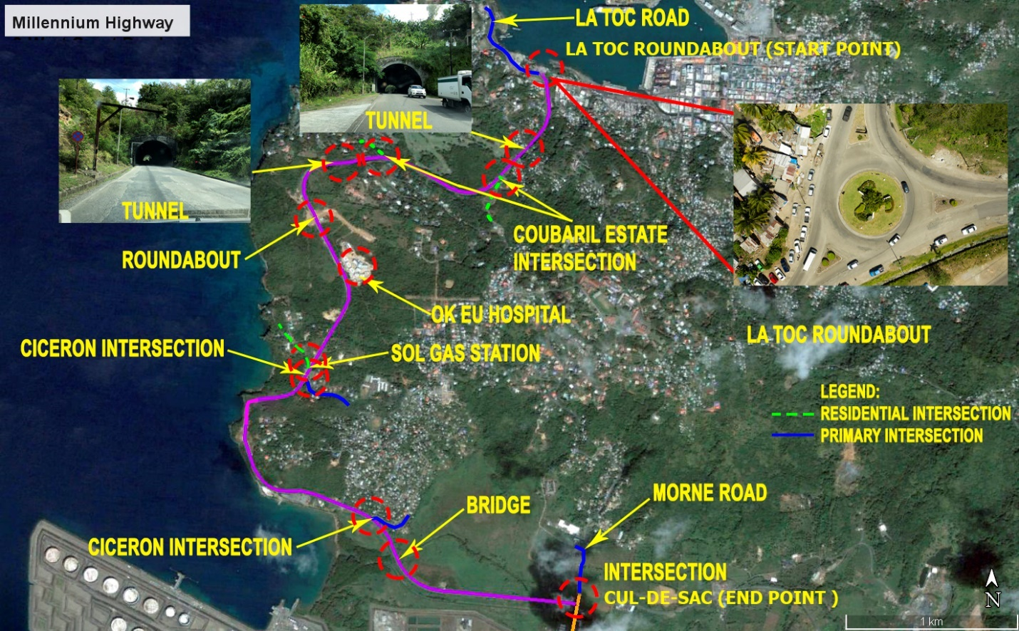

Table 5: Millennium Highway to Cul-De-Sac (Chainage 0+000 – 6+130)
Site Characteristics and Features | Summary Description | Special Consideration
Topography | The MH segment begins at the busy La Toc round about on the west coast close to capital city Castries. The road segment goes a little east before turning west to follow the coast until it reaches Cicerone then turns east again to join the west course road at Cul de Sac.
Geology | The soil in this area is primarily andesite with basaltic agglomerate. The surface geology is a mixture of silt, clay and weathered rocks; around Ciceron the rock is altered andesite. The top soil varies between 0.5 and 1.5 m and drains readily.
Utilities | Buried 66 KV along right shoulder from chainage 0+000 to 6+120 | Underground 66KV electrical lines
 | Buried 150mm PVC Water main from chainage 2+200 to 3+180 | Underground 150mm PVC Water Main
Institutional Facilities | OKEU General Hospital | Alternative Access Required
Commercial Activities | Petrol Station | Chainage 3+080
Major Intersections | Coubaril (Chainage 1+460)  OK EU Hospital (Chainage 2+180)  National Mental Wellness Center (Chainage 2+480)  Ciceron (Chainage 3+150 and Chainage 4+720) | Access to be provided through out construction to be captured in methodology
Bypass Routes | Castries – La Toc – Morne Main  Morne – Cul-de-Sac Main  Ciceron Main | These routes do not allow for the safe navigation of heavy goods vehicles. Local bypasses for light vehicles are available off the Millennium Highway through Coubaril Estate and Ciceron.
Residential Communities and Local Access Requirements | Coubaril  No.4) | Access to be provided through out construction to be captured in methodology
 | Ciceron
 | Residential Access No.1 (Chainage 0+550)
 | Residential Access No.2 (Chainage 0+680)
 | Residential Access No.3 (Chainage 3+310)
 | Residential Access No.4 (Chainage 4+520
 | Residential Access No.5 (Chainage 4+610)

Cul-de-Sac to Anse La Raye and Anse La Raye Bridge

Cul-de-Sac to Anse La Raye and Anse La Raye Bridge Location Map
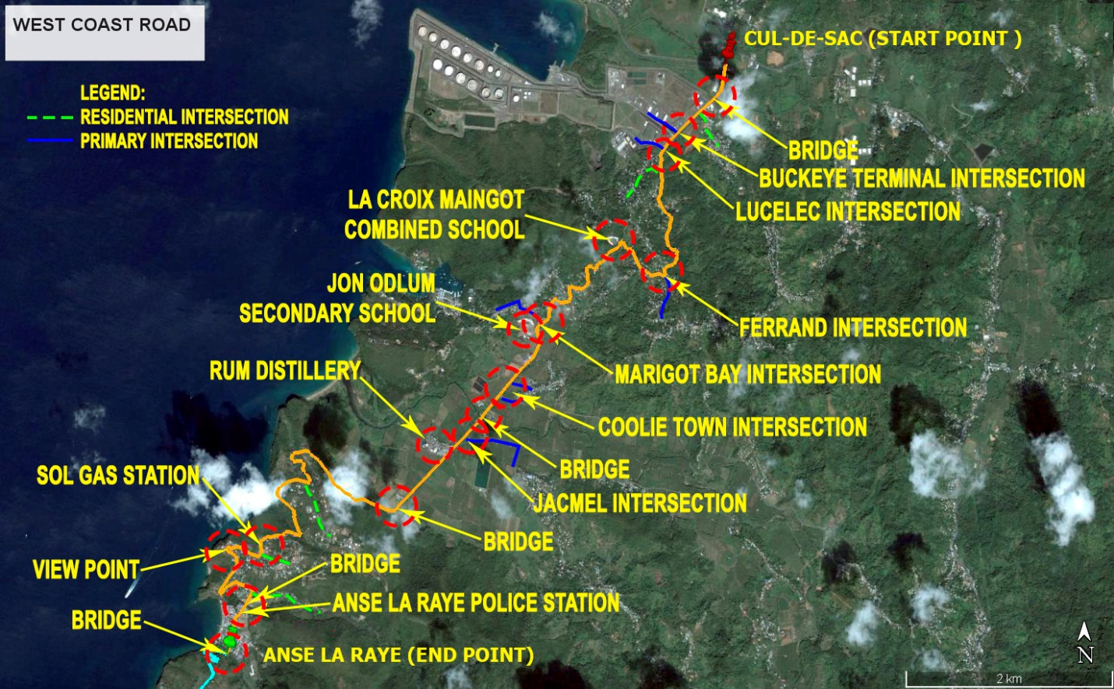

Table 6: Cul De Sac to Anse La Raye and Anse La Raye Bridge (Chainage 0+000 – 11+079)
Site Characteristics and Features | Summary Description | Special Consideration
Topography | This road segments road begins at Cul de Sac and passes through a number of small communities and the Roseau agriculture valley ending at the bridge in Anse La Raye
Geology | Manly alluvial deposits
Utilities | Buried 66 KV along right shoulder from chainage 0+000 to 0+960 | Underground 66KV electrical lines. Contractor to notify utility company before commencing works along this segment.
 | Buried 100mm PVC Water main along left shoulder from chainage 0+000 to 0+960, 5+520 to 5+780, 9+340 to 10+520 and 10+780 to 11+030 | Underground 100mm PVC Water Main. Contractor to notify utility company before commencing works along this segment.
 | Buried 100mm PVC Water main along right shoulder from chainage 0+960 to 4+4790, 8+280 to 9+340 | Underground 100mm PVC Water Main. Contractor to notify utility company before commencing works along this segment.
 | Buried 50mm PVC Water main along left shoulder from chainage 10+520 to 10+780 | Underground 50mm PVC Water Main. Contractor to notify utility company before commencing works along this segment.
Institutional Facilities | St. Lucia Electricity Services (LUCELEC) | Access to be provided through out construction to be captured in methodology
 | Buckeye St. Lucia Terminal
 | Pre-school
 | La Croix Health Centre | Access to be provided through out construction to be captured in methodology
 | La Croix Maingot Combined School
 | Stanley Jon Odlum Memorial Secondary School
 | Anse La Raye Police Station
 | Anse La Raye Combined School
Commercial Activities | #1 Stop Tyre Shop (Chainage 0+140)
 | Massy Stores (Chainage 0+160)
 | Petrol Station (Chainage 0+240)
 | CPJ Fresh Market (Chainage 0+265)
 | West Indies Shipping (Chainage 0+275)
 | Wizo (Chainage 0+310)
 | Rubis Commercial Centre (Chainage 0+450)
 | Commercial Supplies (0+785)
 | Promise Supermarket Bar (Chainage 4+070)
 | Total Construction Supplies (Chainage 4+660)
 | St. Lucia Distillers (Chainage 5+660)
 | Petrol Station (Chainage 9+220)
 | Mini mart (Chainage 10+515)
Major Intersections | Ti Colon (Chainage 1+080 and 2+200) | Access to be provided through out construction to be captured in methodology
 | La Croix Maingot (Chainage 2+270)
 | Fond Manger (Chainage 2+525 and 3+805) | Access to be provided through out construction to be captured in methodology
 | Marigot (Chainage 4+275 and 4+535)
 | Coolie Town (Chainage 4+790)
 | Morne d’Or (Chainage 5+580)
 | Roseau (Chainage 5+660) | Access to be provided through out construction to be captured in methodology
 | Masscre (Chainage 7+980)
 | Au Tabor (Chainage 9+230)
Bypass Routes | Ti Colon | Bypass routes to be upgraded and provision made in the works contract
 | La Croix Barre du’ Chasseau Odsan
 | Coolie Town
 | Morne d’Or
 | Anse La Raye- Venus Road
Residential Communities and Local Access Requirements | Ti Colon | Access to be provided through out construction to be captured in methodology
 | Series of residential accesses from La Croix Maingot to Marigot (chainage 1+390 to 4+500)
 | Fond Manger
 | Marigot
 | Roseau
 | Massacre
 | Au Tabor
 | Anse Cochon

Anse La Raye to Soufriere

- Anse La Raye to Canaries Segment

Anse La Raye to Canaries Location Plan
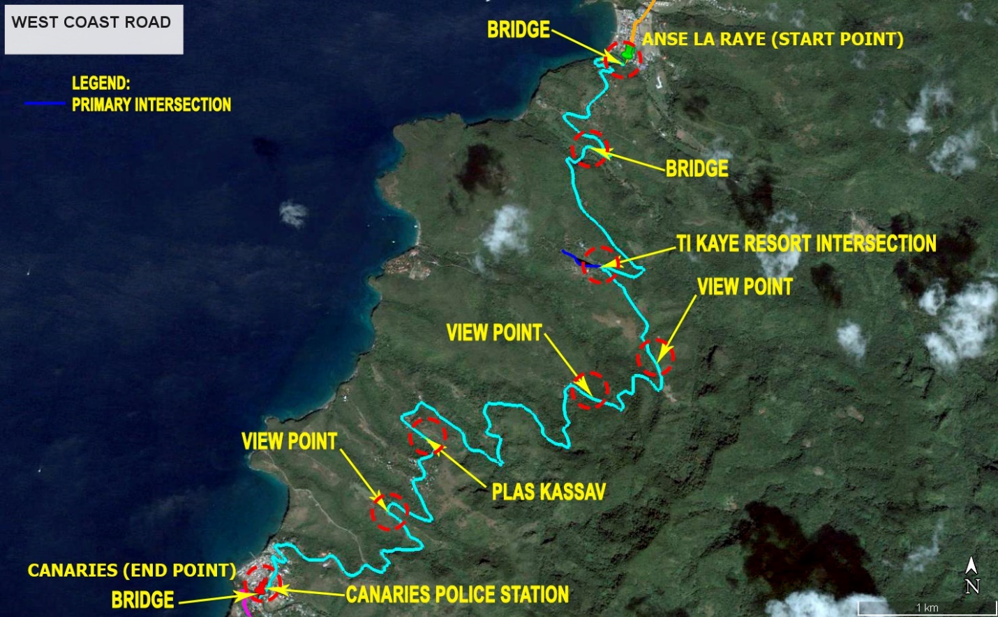

Table 7: Anse La Raye to Canaries Segment (Chainage 0+000 to 11+810)
Site Characteristics and Features | Summary Description | Special Consideration
Topography | The Anse La Raye to Canaries road segment climbs to about 200 feet then winds its way down to the coast at Canaries. There are very few houses along the route and the landscape is dominated by forest.
Geology | Andesite bedrock covered by topsoil composed of weathered rocks, organic matter and clay
Utilities | Buried 100mm PVC Water main along left shoulder from chainage 6+900 to 8+500, 11+180 to 11+400, 11+510 to 11+580 and 11+680 to 11+790 | Underground 100mm PVC Water Main. Contractor to notify utility company before commencing works along this segment.
 | Buried 100mm PVC Water main along right shoulder from chainage 8+500 to 8+740, 11+400 to 11+510 and 11+580 to 11+680
Institutional Facilities | Canaries Infant School  Canaries Primary School  Canaries Police Station | Access to be provided through out construction to be captured in methodology
Commercial Activities | Plas Kassav | Access to be provided through out construction to be captured in methodology
 | Ti Kaye Resort & Spa
Major Intersections
Bypass Routes | None
Residential Communities and Local Access Requirements | Anse Cochon  Anse La Verdure  Canaries Village | Access to be provided through out construction to be captured in methodology

- Canaries to Soufriere Segment

Canaries to Quarte Chemin Location Plan
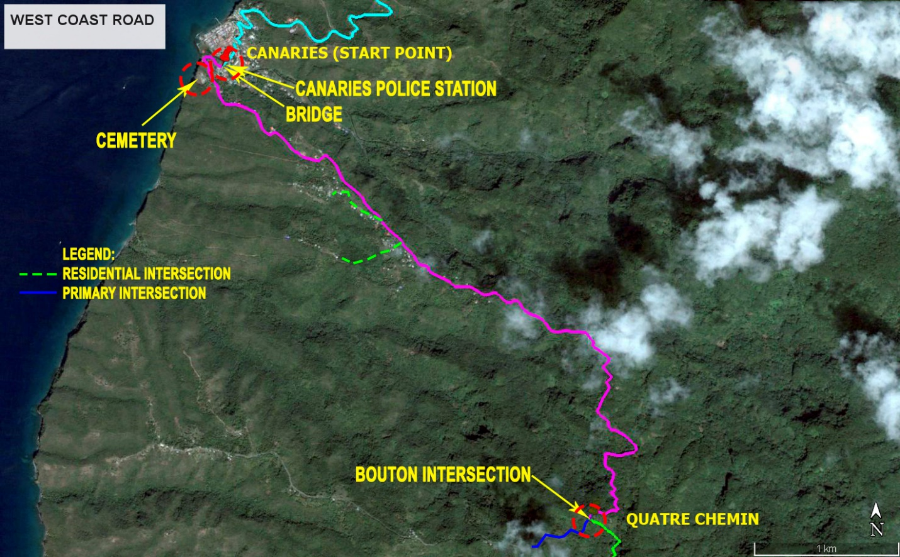
Quarte Chemin to Soufriere Location Plan
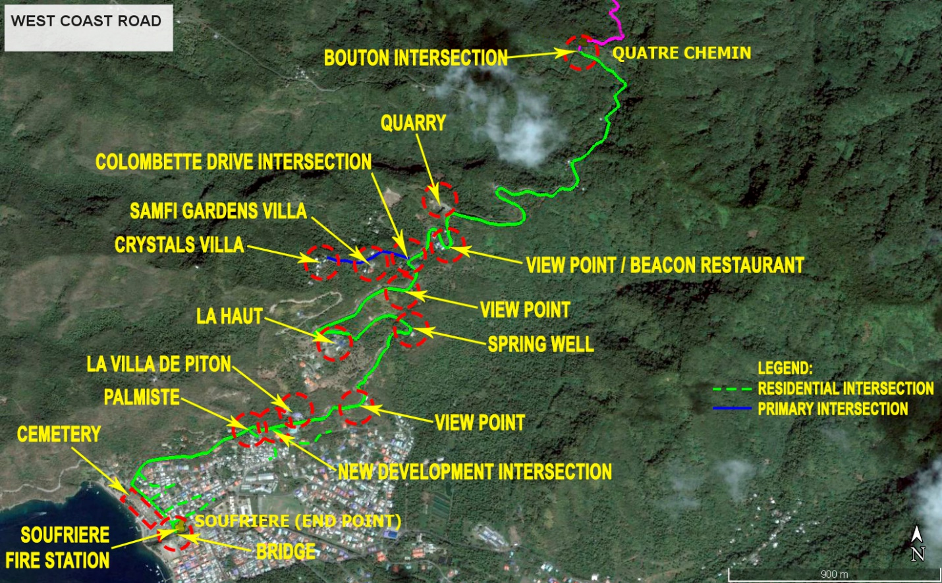

Table 8: Canaries to Soufriere Segment (Chainage 0+000 to 10+990)
Site Characteristics and Features | Summary Description | Special Consideration
Topography | Canaries to Quarte Chemin- This segment of A20 starts at Canaries on the coast and goes east inland climbing to 250 feet to Quatre Chemin Like the connecting segment (Anse La Raye-Canaries), this one passes through dense forest with little human activity along the way.  Quarte Chemin to Soufriere- This road segment traverses rugged terrain below the 200 feet contour and a little inland as it moves from Quatre Chemin, a sparsely populated community, to the more densely populated town of Soufriere on the coast.
Geology | Canaries to Quarte Chemin- Basal and andesite rocks covered with thin topsoil  Quarte Chemin to Soufriere- Rocks from the Soufrière Volcanic series
Utilities | Buried 66 KV along right shoulder from Canaries to Quarte Chemin | Underground 66KV electrical lines. Contractor to notify utility company before commencing works along this segment.
 | Buried 11 KV along right shoulder from Canaries to Quarte Chemin | Underground 11KV electrical lines. Contractor to notify utility company before commencing works along this segment.
 | Buried 100mm PVC Water main along right shoulder from Chainage 0+990 to 3+140 and 9+800 to 10+700 | Underground 100mm PVC Water Main. Contractor to notify utility company before commencing works along this segment.
 | Buried 50mm PVC Water main along left shoulder from Chainage 0+470 to 3+050 | Underground 50mm PVC Water Main. Contractor to notify utility company before commencing works along this segment.
 | Buried 100mm PVC Water main along left shoulder from Chainage 10+700 to 10+992 | Underground 100mm PVC Water Main. Contractor to notify utility company before commencing works along this segment.
 | Buried 50mm PVC Water main along right shoulder from Chainage 3+140 to 5+900 | Underground 50mm PVC Water Main. Contractor to notify utility company before commencing works along this segment.
Institutional Facilities | Soufriere Infant School | Access to be provided through out construction to be captured in methodology
 | Soufriere Primary School
 | Soufriere Secondary School
 | Soufriere Fire Station
Commercial Activities | Quarry (Chainage 7+590 RHS)
 | Beacon Restaurant (Chainage 7+765 LHS) | Access to be provided through out construction to be captured in methodology
 | Entrance to Villas (Chainage 8+070 RHS)
 | Jade Mountain Resort (Chainage 10+710 RHS)
 | Anse Chastanet Hotel (Chainage 10+710 RHS)
 | Soufriere Beach Park (Chainage 10+740 RHS)
Major Intersections | Bouton (Chainage 5+900 RHS)  Palmiste (Chainage 10+110 LHS)  Anse Chastanet (Chainage 10+710 RHS)  Fond Benier (Chainage 10+630 LHS)  Soufriere Beach Park (Chainage 10+740 RHS)  Soufriere Cemetery (Chainage  10+960 RHS) | Access to be provided through out construction to be captured in methodology
Bypass Routes | Palmiste Road | Bypass routes to be upgraded and provision made in the works contract.
 | From Soufriere Town to Castries – East Coast Road | Alternative route to and from Castries
Residential Communities and Local Access Requirements | Bouton  Belvedere  La Haut  New Development  Palmiste  Mahaut  Mamin  Soufriere Town | Access to be provided through out construction to be captured in methodology

