# saint lucia coat of arms

**Ministry of Education, Sustainable Development, Innovation, Science, Technology and Vocational Training**

## PRESS RELEASE

**2025 OAS-CMU PAEC SCHOLARSHIP OPPORTUNITY**

The General Secretariat of the Organization of American States (GS/OAS) and Caribbean Maritime University (CMU) in Jamaica have come together to support outstanding individuals from the Americas by awarding the following academic scholarship to assist undergraduate and graduate students.

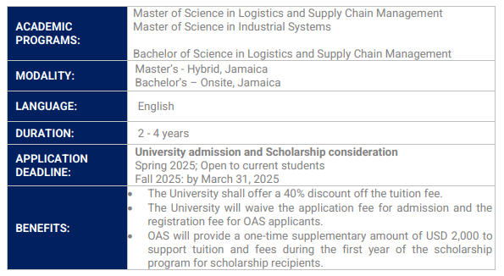

**The receipt of scholarship benefits is subject to the scholarship recipient's satisfactory academic performance and the funds' availability. To receive these benefits, the scholarship recipient must not be reported with an unsatisfactory academic performance due to absences or failing courses.**

**SCHOLARSHIP APPLICATION PROCESS:**

* To be considered for an OAS-CMU PAEC Scholarship, students must be admitted or registered in one of the programs of study at CMU to start during the Spring 2025 or Fall of 2025.
* Upon admission to one of the programs of study at CMU, the applicant will automatically be considered a candidate for the OAS-CMU PAEC scholarship.
* Applicants must follow the OAS-CMU PAEC scholarship process.
* The applicant must submit all supporting documents as required for consideration.

For additional information on this scholarship offer please visit: <https://bit.ly/oas_cmu>.

**EXPENSES NOT COVERED BY THIS SCHOLARSHIP:**

Expenses not covered by this scholarship are the sole responsibility of the scholarship recipient:

• remaining cost of tuition and fees;

• health insurance, if applicable;

• housing and food;

• books and supplies;

• any additional fees not covered by the OAS-CMU PAEC Scholarship

**ELIGIBILITY:**

To be considered for this scholarship opportunity, the applicant must:

• Be registered for the Fall 2024 or admitted to the Spring 2025 semester at CMU;

• Be a citizen and/or permanent legal resident of any OAS member state, except Jamaica.

The following applicants are not eligible:

• Current OAS Scholarship recipients

• GS/OAS staff and their immediate relatives or GS/OAS consultants.

• OAS Permanent officials and their immediate relatives.

**SCHOLARSHIP CONTACT INFORMATION**:

Questions regarding this scholarship opportunity should be sent to [scholarships@oas.org](mailto:scholarships@oas.org) under the title "OAS-CMU Scholarship Programme."

Note: The General Secretariat of the Organization of American States (GS/OAS) reserves the right to cancel this scholarship announcement at any time during the process. The GS/OAS and its staff will not be responsible for any action that derives from the information in this announcement.

**The Deadline for the submission of applications is March 31, 2025.**

***… End of Press Release******…***

**January 22, 2025**

*/bm*