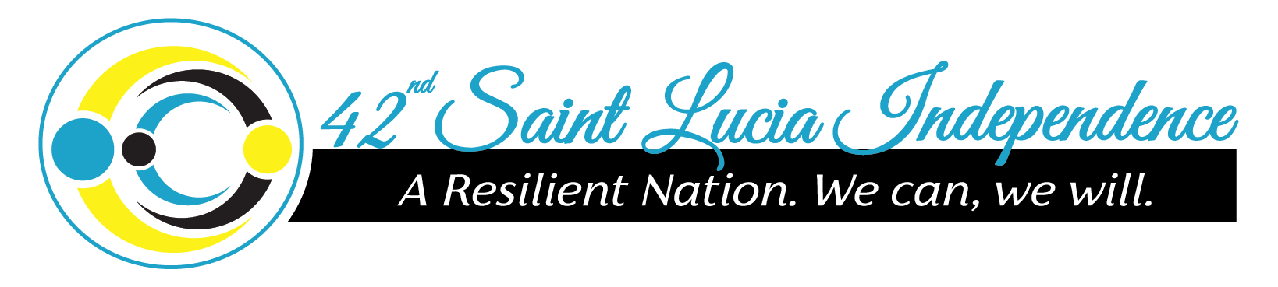

“We Can. We Will.”

**Prime Minister Honourable Allen Chastanet**

**Address on the Occasion of Saint Lucia’s 42nd Independence Anniversary**

Monday February 22nd 2021

Happy Independence Day to All Saint Lucians.

What a difference a year makes! A year ago, when I addressed you on the occasion of our 41st Independence anniversary, there was little mention in our island of the word ‘Coronavirus’ or ‘COVID’.

We were together for an amazing celebration of everything Saint Lucian. In fact, for the past few years our Independence celebrations have truly been “all in” and outstanding, with the addition of the National Independence Parade and displays of branding and cultural presentations befitting the occasion.

In my address to you a year ago, I told you about the advances that our country had made since 1979, along with the more recent successes of our government since assuming the mantle of leadership in 2016. It was clear for all to see that Saint Lucia was again back on track with its development.

Covid-19 has impacted this development and there is no denying that there will be setbacks. We have had immense revenue losses and had to reallocate a lot of our resources to fight the pandemic. But you would have heard me say repeatedly over the past year that Covid-19 will not define us. Nor will we allow it to deter us.

On this occasion therefore, my message to the people of Saint Lucia, is forward-looking, hence the theme for this year’s celebrations: **“A Resilient Nation: We can. We will”.**

The Government that I have the honour to lead is one that faces challenges head on and leads from the front. Even while we continue to fight COVID, we must also begin to look beyond it, to position ourselves and our country to overcome this pandemic and the scars it will leave on our country in much the same way that we have overcome every natural disaster or challenge that has confronted us in the past, especially since Independence 42 years ago.

Then there were the economic challenges starting with the international oil crisis that erupted in the 1970s, the restrictions on access to the European market for our bananas, the world economic and financial crisis of 2008, as well as the hardships of the post-independence political problems of 1979, and more recently, the consecutive years of economic decline that this government inherited and is now redressing.

On every one of these occasions, Saint Lucians took up the challenge and put their shoulders to the wheel, turning each setback into an opportunity to build back better, whether it was the country, their homes or their very lives, because many of our people recognize that as an independent nation, we have responsibilities.

It is one of the reasons we took up the challenge of independence in the first place: to become makers of our own destiny. We recognized too that while outside countries and institutions would give us a helping hand, in the final analysis the task of developing Saint Lucia, is ours.

This 42nd Independence anniversary proffers us the opportunity to appreciate how far we have come, but more importantly, how far we still have to go.

As the resilient nation and people that we are, we can and we will get that job done. This year’s celebrations, though different, will give the entire country reason to celebrate and improve our determination to emerge out of the COVID pandemic. Wearing of face masks is a crucial element in curtailing the spread of the virus and I have said before the wearing of our mask is how we show love for country. Following the protocols is how we are truly being our brother and sister’s keeper.

The Independence Committee has also planned a series of panel discussions geared to examine critical issues, such as our Independence History with a discussion with Rick Wayne and Peter Josie and a discussion by the finance team on Sustainable Economic Development. This will include an open forum for businesses to discuss how they are staying afloat during these difficult times.

In celebrating Saint Lucia, we also honour businesses that have contributed to the financial success of this country over the last 42 years; The Investiture Ceremony, recognizing some of our outstanding Saint Lucians, will be held in early March.

The past year has been particularly hard on our musicians and entertainers, many of whom have been robbed of the opportunity of earning a livelihood. As a country that has benefitted greatly from their talents, we owe it to them to give them our support. I took great pride in working on the Prime Minister’s playlist and I thank Verve St Lucia and the Independence Committee for this great idea.

All activities will be held virtually, meaning that there will be no crowds in public places to cheer on those participating. But that should not detract from the enjoyment that I am sure we all will feel, watching from a distance, as it were.

I congratulate Chairperson Hon. Jeannine Giraudy-McIntyre and the entire Independence Committee for the hard work in putting the activities together. I thank all who have participated in the online challenges and competitions.

As we headed into our Independence weekend, we had the good news that the fight against COVID entered a new phase: we began the vaccination programme. I am so proud of all the nurses, doctors, firemen and police that have already received the vaccine.

The Ministry of Health’s pre-registration process has begun and we are encouraged by the thousands of Saint Lucians who have indicated they are ready to take the vaccine. I want to repeat: **it is free and it is voluntary.**

The Ministry of Health is putting out all the information at its disposal on the vaccines for the education of the public. I ask everyone to avail themselves of this opportunity so that individually we can all make decisions that are based on factual information rather than feelings or rumours.

Meanwhile, we must continue to be vigilant. We are not out of the woods. While we have every confidence that the most recent Covid-19 prevention and control measures announced by the government to contain the spread of the virus in Saint Lucia are working, we would like every Saint Lucian to continue to practice the protocols that have brought us success in the past.

We must wear a mask.

We must stay home when we are sick.

We must remain socially distanced.

I know that many of you are hurting. Despite our efforts to ensure we provided income support and reopened the economy, some people have still not been able to go back to work or open their businesses and the impact of COVID is still very real. It is because we care that our Government has introduced measures to reach the most vulnerable and we are constantly looking at ways to reach even more people and stimulate the economy.

The fact is COVID-19 has dictated certain policies, as we try to minimize social interaction and movement. It has been a mammoth task and as a result some persons and businesses have been more severely impacted than others: such as our local attractions, restaurants, bars and bus drivers, to name a few. This weighs heavily on our minds as leaders but we need to keep COVID-19 under control while also allowing some sectors to open.

Once we can more significantly reduce the number of COVID-19 cases, we will open up even more sectors. This will take immense cooperation.

I say to all of you today there has never been a bigger sense of purpose than Saint Lucia responding as one to this pandemic. Our country has struck a balance, thanks in great part, to the thousands of frontline workers who toiled at great risk during the past eleven months to serve us all so well. You all have our eternal gratitude.

There are so many other Saint Lucians who have stepped up over the past year and though I may not get to mention all of you, and we often mention those in the field of security and health, you are not forgotten: the fisher folk, the gas attendants, the supermarket staff, the minibus drivers, SLASPA and customs officers. To so many of you, I say Thank You.

I assure the entire nation that we are working to have Saint Lucia come through this difficult time and continue to build on what we started: A Saint Lucia with improved roads, more community centers, a world class Education system, smart health centers, amazing sporting facilities, village tourism, a better water supply and all the things we are working towards to lift the standard of living for all.

Let us all work to continue building a disaster-resilient economy. An economy where our society shares in the gains and everyone has a fair shot at success.

A Saint Lucia where our social safety net is strengthened, our people are working, our economy is growing and responding, our healthcare system is boosted and our people are secure.

As a Government we are fully committed to this quest. **Saint Lucia inspires us to keep working.**

As we all enjoy a quiet 42nd Independence Anniversary let’s use this time to reflect and recommit to building a new Saint Lucia for generations to come. We can and We will succeed.

A Happy Independence Day to all. May God bless you all and May God continue to bless our beautiful island home Saint Lucia.